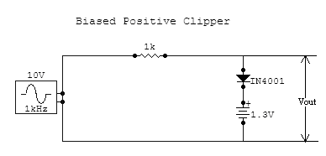

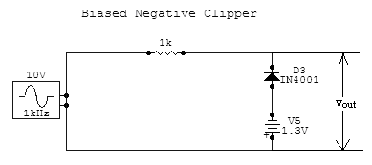

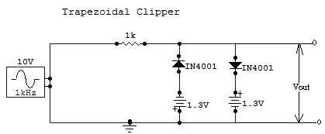

PROCEDURE

- Set up the circuit on the bread board after testing each component.
- Designed input is given by using a function generator.
- Connect the output of the CRO.
- Observe the clipped and clamped output waveforms.

